OpenClassRooms

Project 4 - Optimize an Existing Website

Complete by Mihail Tudos

Table of Contents

Project 4 – Report 3

Audit report 3

Google Lighthouse report before optimization 3

Accessibility and Usability report before the optimization 4

HTML validation report 5

CSS report before optimization 5

Google Lighthouse report after optimization 6

Validation after the optimization 7

Optimization process 8

Conclusion 11

# Project 4 – Report

## Audit report

### Google Lighthouse report before optimization

When analysing the project files received form Mike the following result were registered using Google Lighthouse.

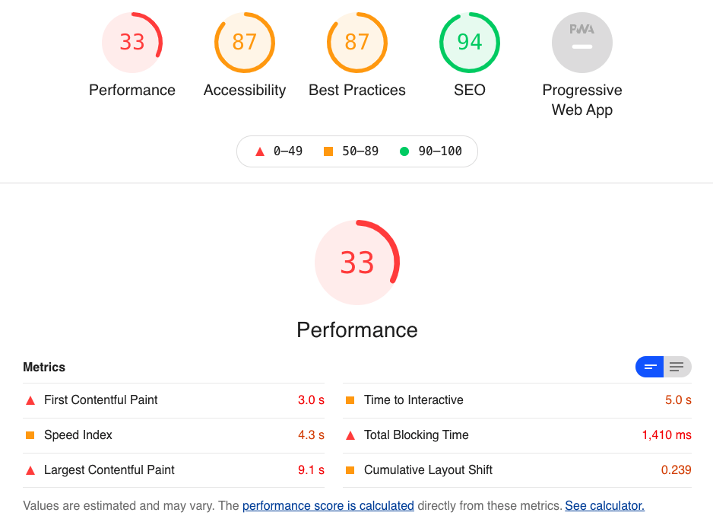

Figure 1 Home page google report (received files)

Figure 2 Contact page google report (received files)

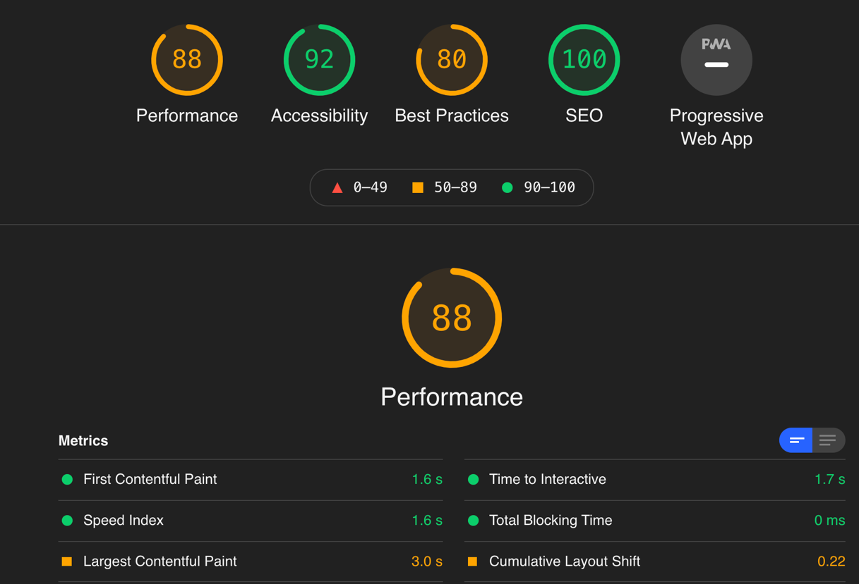

### Accessibility and Usability report before the optimization

Figure 3 Usability report before optimization

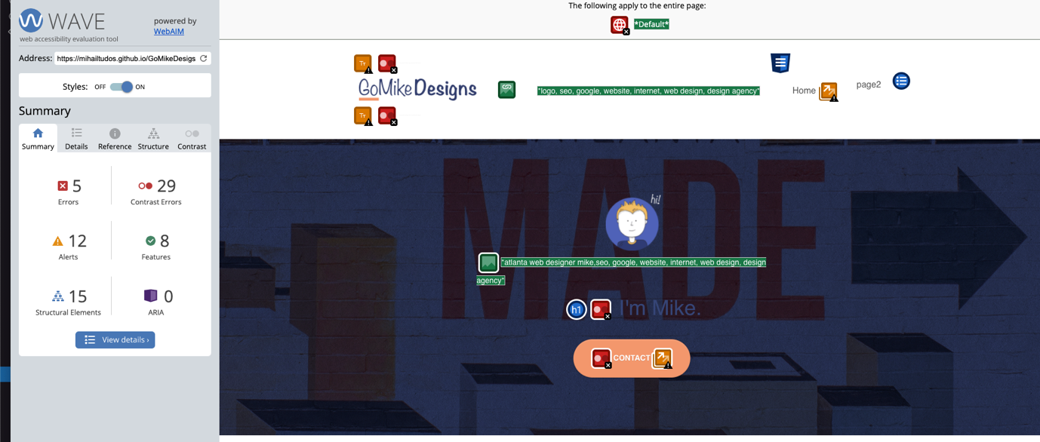

Figure 4 Accessibility report

### HTML validation report

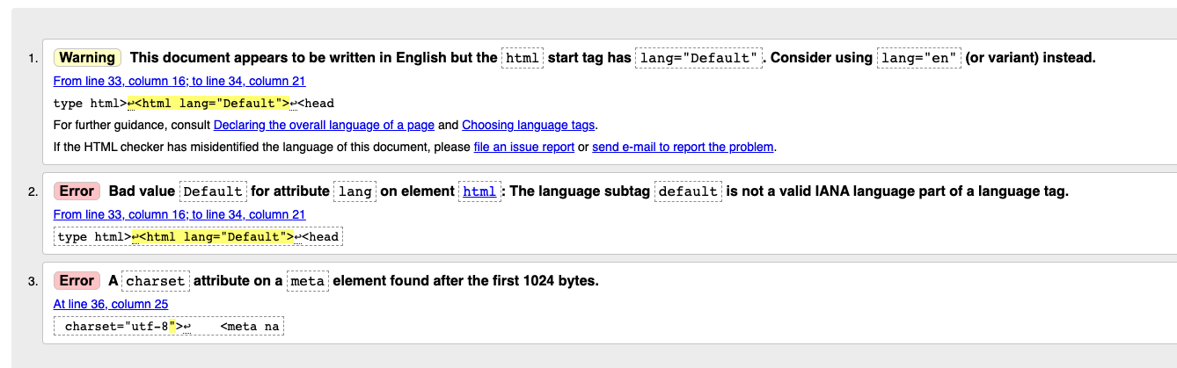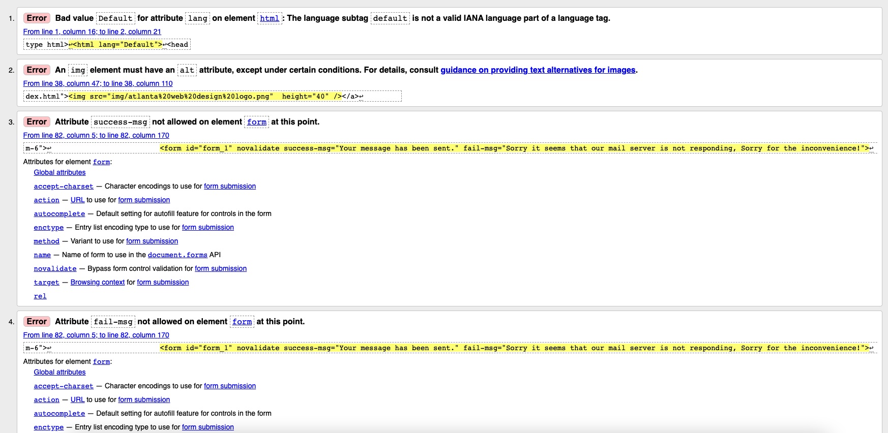

Figure 5 HTML validation report

### CSS report before optimization

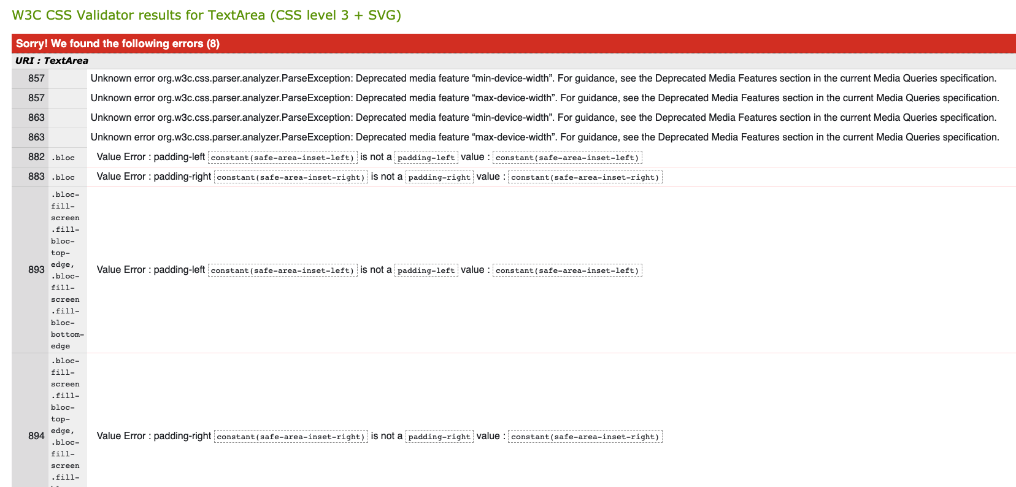

Figure 6 CSS validation report

### Google Lighthouse report after optimization

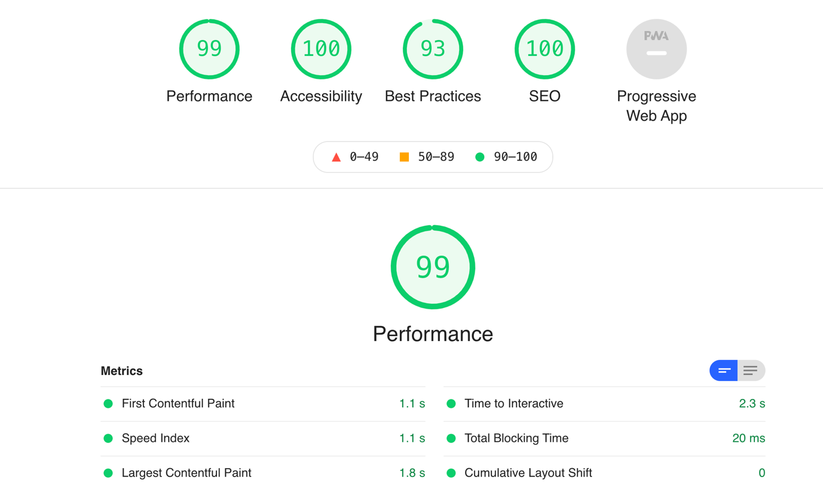

Figure 7 Google Lighthouse report after optimization for home page

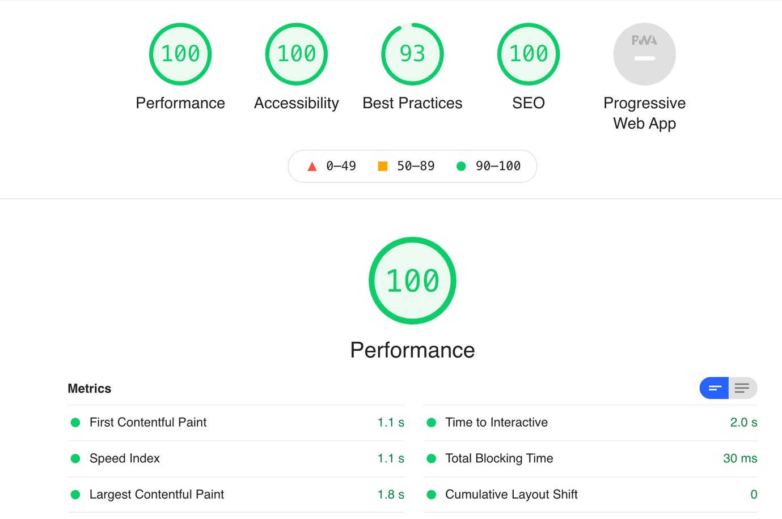

Figure 8 Google Lighthouse report after optimization for contact page

### Validation after the optimization

Figure 9 HTML validation results after optimization

Figure 10 CSS validation results after optimization

## Optimization process

To achieve the above results the following techniques and aspects of GoMike Designs website were addressed:

**Keywords**

Metatag removed since google doesn’t count it, and I don’t want the website to look outdated since google ignores it for a decade now.

**Description metatag**

Updated the description metatag with “GoMike Designs, based in Atlanta, uses online and logo design to help local businesses achieve their objectives.” to better describe the main scope of the website but also to include local (location) elements.

**Title metatag**

Title is missing, there is only a. (dot) as the title of the page which is not SEO good practice neither a user-friendly technique. Added a descriptive title for every page.

**Hidden keyword (Blackhat)**

Removed all Blackhat elements from the page and building content that helps highlight those keywords.

**Accessibility**

Semantic HTML makes webpages accessible for mobile devices and for people with disabilities as well. This is because screen readers and browsers can interpret the code better. Therefore, I restructured the markup to give the content as much meaning as possible.

Also added alt tags to images.

**Resizing and compressing images**

I reduced the size of the available images by resizing and compressing into a modern format (webp).

**Lazy loading images**

Allowing images to load when needed which saves bandwidth and reduces the website download time.

**Missing lang tag**

Language tag was set to default hence I changed it to en since the main audience is Atalanta (USA). This HTML attribute is used by various programs, search engines included, to help figure out what language page is written in. This is helpful when trying to match the right content to the right user.

**Content blocking resources were moved at the end and minified**

To reduce the impact of resources such as CSS and Scripts no loading time I have moved the scripts at the bottom of the page and defer-ed their load. Also preloaded CSS and fonts to allow the page to display properly the content.

M**issing sitemap file**

There is no sitemap link of file currently available on the website. A sitemap is a file where you provide information about the pages, videos, and other files on your site, and the relationships between them. Search engines like Google read this file to crawl your site more efficiently. A sitemap tells Google which pages and files you think are important in your site and provides valuable information about these files.

N**aming accordingly pages, internal links, and page files**

Apparently, there are a bunch of links that are incorrectly used, named, and linked. Therefore, to provide a good user experience and help Google easier crawl the site I have removed the unnecessary links, named and linked properly existing links and also named the files to match appropriate link definition.

**Only one h1 on the page and semantic HTML needs to be used**

To support content readers that may land on the page I have used appropriate HTML semantic tags (markup).

**Using proper styling rather than br HTML tags**

I have used more CSS to stile those margins and paddings where br tags were used.

**Have resized and given fixed hight and width to the images on the website**

This technique allowed to serve images that are appropriately sized and therefore save cellular data and improve load time which also helped to reduce layout shifts and improve CLS

**Removed CSS content**

Reduced unused rules from stylesheets and other CSS files (font awesome) not used for above-the-fold content to decrease bytes consumed by network activity. Also preloaded the font-display CSS to ensure text is user-visible while web fonts are loading

**Form missing labels linked to inputs**

There is a form on the contact page that has multiple inputs without labels and hence not a good user practice since it might lead to accessibility and usability issues.

# Conclusion

All the above taken steps have led to a considerable performance, usability, accessibility and SEO improvements. However, there is more work to follow in order to improve aspects such as compressing text based files on server delivery, delivering optional images when browsers cannot access webp format, deal with 3-party front end libraries that apparently present security issues, etc.